**Gel electrophoresis**

* A technique used to separate DNA fragments and other macromolecules by size and charge. **Gel electrophoresis** is a technique used to separate DNA fragments according to their size.
* DNA samples are loaded into wells (indentations) at one end of a gel, and an electric current is applied to pull them through the gel.
* DNA fragments are negatively charged, so they move towards the positive electrode. Because all DNA fragments have the same amount of charge per mass, small fragments move through the gel faster than large ones.
* When a gel is stained with a DNA-binding dye, the DNA fragments can be seen as **bands**, each representing a group of same-sized DNA fragments.

**Gel electrophoresis** is a technique used to separate DNA fragments (or other macromolecules, such as RNA and proteins) based on their size and charge. Electrophoresis involves running a current through a gel containing the molecules of interest. Based on their size and charge, the molecules will travel through the gel in different directions or at different speeds, allowing them to be separated from one another.

All DNA molecules have the same amount of charge per mass. Because of this, gel electrophoresis of DNA fragments separates them based on size only. Using electrophoresis, we can see how many different DNA fragments are present in a sample and how large they are relative to one another. We can also determine the absolute size of a piece of DNA by examining it next to a standard "yardstick" made up of DNA fragments of known sizes.

As the name suggests, gel electrophoresis involves a gel: a slab of Jello-like material. Gels for DNA separation are often made out of a polysaccharide called **agarose**, which comes as dry, powdered flakes. **Agarose** is a polysaccharide, generally extracted from certain red seaweed. It is a linear polymer made up of the repeating unit of agarobiose, which is a disaccharide made up of D-galactose and 3,6-anhydro-L-galactopyranose. When the agarose is heated in a buffer (water with some salts in it) and allowed to cool, it will form a solid, slightly squishy gel. At the molecular level, the gel is a matrix of agarose molecules that are held together by hydrogen bonds and form tiny pores. The greater the agarose concentration, the smaller the pores created in the gel matrix, and the more difficult it is for large linear DNA molecules to move through the matrix. Changing the agarose concentration changes the size of the sieve matrix of the gel. However, there is an upper and lower limit to accurate separation of DNA molecules using agarose gel electrophoresis

At one end, the gel has pocket-like indentations called **wells**, which are where the DNA samples will be placed:

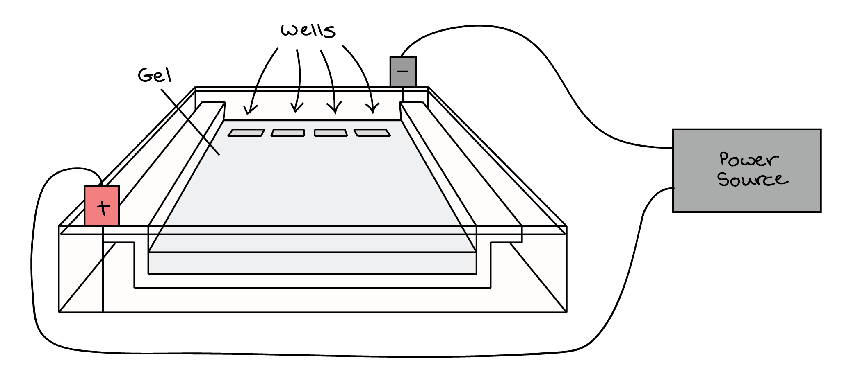

Diagram indicating the set up of a horizontal gel electrophoresis

Before the DNA samples are added, the gel must be placed in an electrophoresis tank. One end of the tank is hooked to a positive electrode (anode), while the other end is hooked to a negative electrode (cathode). The main body of the tank, where the gel is placed, is filled with a salt-containing buffer solution known as **TAE buffer. TAE buffer** is a **buffer** solution containing a mixture of Tris base, acetic acid and EDTA. In molecular biology it is used in agarose **electrophoresis** typically for the separation of nucleic acids such as DNA and RNA. It is made up of Tris-acetate **buffer**, usually at pH 8.3, and EDTA, which sequesters divalent cations and can conduct current. The buffer fills the gel box to a level where it just barely covers the gel. **Buffers** in gel **electrophoresis** are used to provide ions that carry a current and to maintain the pH at a relatively constant value. Also TBE buffer can be used. **TBE** or **Tris/Borate/EDTA**, is a [buffer solution](https://en.wikipedia.org/wiki/Buffer_solution) containing a mixture of [Tris base](https://en.wikipedia.org/wiki/Tris), [boric acid](https://en.wikipedia.org/wiki/Boric_acid) and [EDTA](https://en.wikipedia.org/wiki/EDTA).

In molecular biology, TBE and [TAE](https://en.wikipedia.org/wiki/TAE_buffer) buffers are often used in procedures involving [nucleic acids](https://en.wikipedia.org/wiki/Nucleic_acids), the most common being [electrophoresis](https://en.wikipedia.org/wiki/Electrophoresis). [Tris](https://en.wikipedia.org/wiki/Tris)-acid solutions are effective buffers for slightly basic conditions, which keep DNA deprotonated and soluble in water. EDTA is a [chelator](https://en.wikipedia.org/wiki/Chelation) of divalent [cations](https://en.wikipedia.org/wiki/Cations), particularly of [magnesium](https://en.wikipedia.org/wiki/Magnesium) (Mg2+). As these ions are necessary co-factors for many enzymes, including contaminant [nucleases](https://en.wikipedia.org/wiki/Nucleases), the role of the EDTA is to protect the nucleic acids against enzymatic degradation. But since Mg2+ is also a co-factor for many useful DNA-modifying enzymes such as [restriction enzymes](https://en.wikipedia.org/wiki/Restriction_enzyme) and [DNA polymerases](https://en.wikipedia.org/wiki/DNA_polymerase), its concentration in TBE or TAE buffers is generally kept low (typically at around 1 [mM](https://en.wikipedia.org/wiki/Concentration#Molarity)).

The end of the gel with the wells is positioned towards the negative electrode. The end without wells (towards which the DNA fragments will migrate) is positioned towards the positive electrode.

Once the gel is in the tank, each of the DNA samples we want to examine is carefully transferred/loaded into one of the wells. One well is reserved for a **DNA ladder/yardstick**, a standard reference that contains DNA fragments of known molecular weights. Commercial DNA ladders come in different size ranges, so we would want to pick one with good "coverage" of the size range of our expected fragments.

Next, the power to the gel box is turned on, and current begins to flow through the gel. The DNA molecules have a negative charge because of the phosphate groups in their sugar-phosphate backbone, so they start moving through the matrix of the gel towards the positive pole. When the power is turned on and current is passing through the gel, the gel is said to be **running/migrating**.

A typical voltage for running an agarose DNA gel would be in the range of 80 - 120 V. A higher voltage will make the gel run faster, but may also melt it if it runs for a long period of time. A lower voltage will make the gel run more slowly.

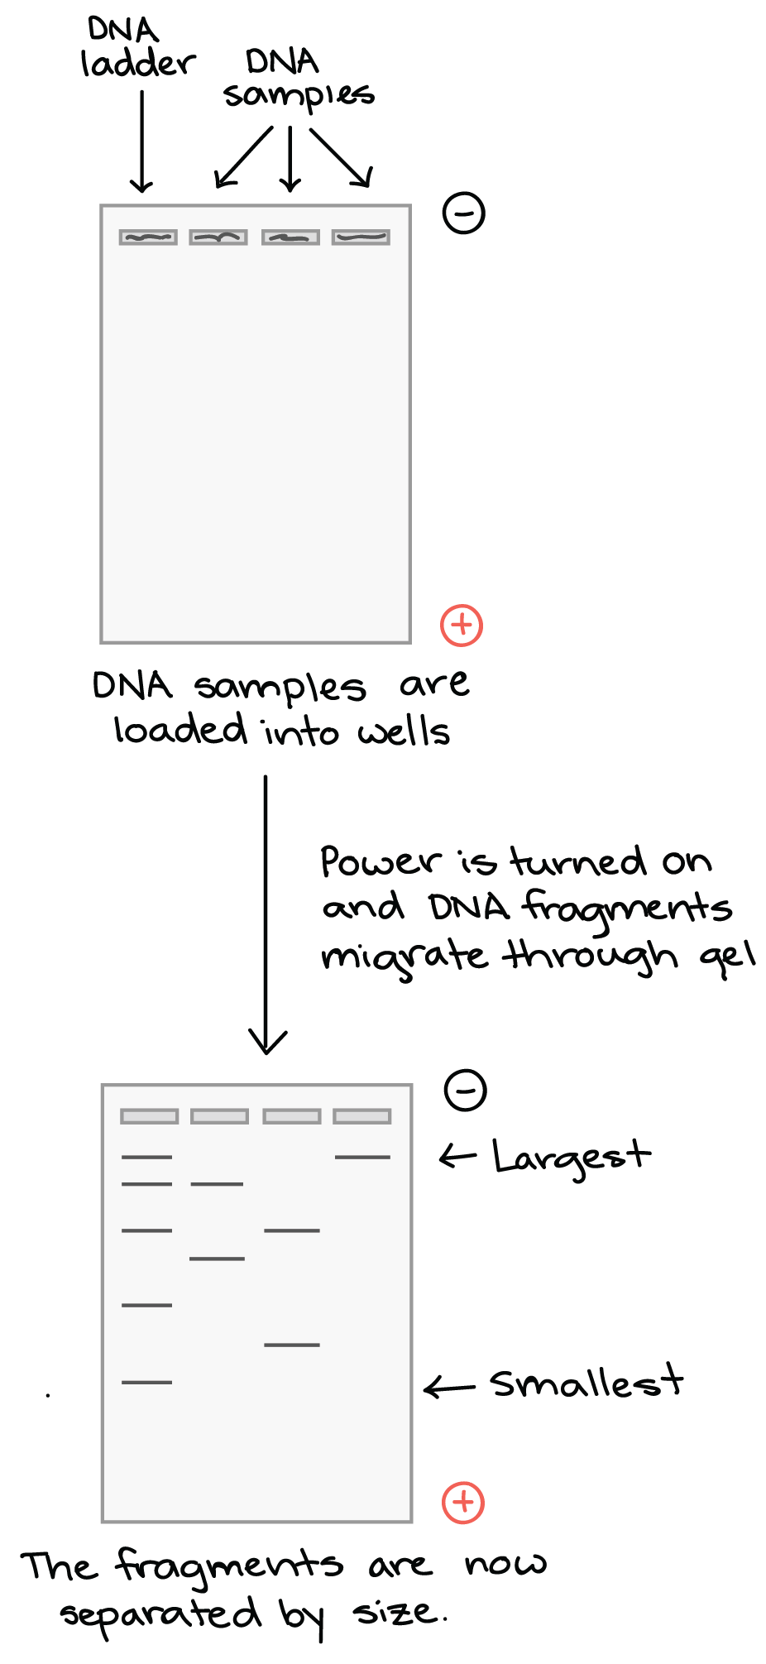

As the gel runs, shorter pieces of DNA will travel through the pores of the gel matrix faster than longer ones. After the gel has run for awhile, the shortest pieces of DNA will be close to the positive end of the gel, while the longest pieces of DNA will remain near the wells. Very short pieces of DNA may run right off the end of the gel if the electrophoretic current is left on for too long. To ensure this does not happen and that DNA sample does not run out of the gel a tracking dye is usually incorporated as the DNA is being loaded. The most common tracking dye is usually referred to as **bromophenol blue** and it gives the colourless DNA a blue color in solution and on the gel. The dye is usually inert and does not affect the structure of the DNA. The usual tracking dye is bromophenol blue in a 50-percent glycerol solution. Bromophenol blue colors the sample bright blue so that it is easy to track its progress through the gel. When the tracking dye has traveled about 3/4 of the length of the gel, it is time to turn off the electrical current. The tracking dye is dense because of its high concentration of glycerol. That makes the DNA samples sink into the loading slots of the gel, rather than floating away in the solution above the gel that carries the electrical current. Bromophenol blue migrates through an agarose solution at about the same rate as a DNA strand containing 300 base pairs. If you want to track the progress of larger DNA strands, you can use a tracking dye with **xylene cyanol**, which migrates at about the same rate as a DNA strand with 4,000 base pairs.\

Once the fragments have been separated, we can examine the gel and see what sizes of bands are found on it. When a gel is stained with a DNA-binding dye (eg ethidium bromide, Propidium iodide that are usually added to the DNA sample during loading into the well) and placed under UV light, the DNA fragments will glow, allowing us to see the DNA present at different locations along the length of the gel.

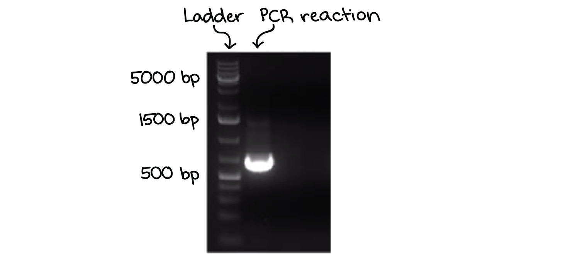

The *bp* next to each number in the ladder indicates how many *base pairs* long the DNA fragment is

A well-defined “line” of DNA on a gel is called a **band**. Each band contains a large number of DNA fragments of the same size that have all traveled as a group to the same position. A single DNA fragment (or even a small group of DNA fragments) would not be visible by itself on a gel.

By comparing the bands in a sample to the DNA ladder, we can determine their approximate sizes. For instance, the bright band on the gel above is roughly 700 base pairs (bp) in size.

